* **ULTRASONIC SENSOR**:-
* **Code**:-

const int trigPin = 9;

const int echoPin = 10;

void setup()

{

Serial.begin(9600);

}

void loop()

{

long duration, inches, cm;

pinMode(trigPin, OUTPUT);

digitalWrite(trigPin, LOW);

delayMicroseconds(2);

digitalWrite(trigPin, HIGH);

delayMicroseconds(10);

digitalWrite(trigPin, LOW);

pinMode(echoPin, INPUT);

duration = pulseIn(echoPin, HIGH);

inches = microsecondsToInches(duration);

cm = microsecondsToCentimeters(duration);

Serial.print(inches);

Serial.print("in, ");

Serial.print(cm);

Serial.print("cm");

Serial.println();

delay(100);

}

long microsecondsToInches(long microseconds)

{

return microseconds / 74 / 2;

}

long microsecondsToCentimeters(long microseconds)

{

return microseconds / 29 / 2;

}

* **Datasheet**:-

Ultrasonic Ranging Module HC - SR04

Ultrasonic ranging module HC - SR04 provides 2cm - 400cm non-contact measurement function, the ranging accuracy can reach to 3mm.

The modules includes ultrasonic transmitters, receiver and control circuit.

The basic principle of work:

(1) Using IO trigger for at least 10us high level signal.

(2) The Module automatically sends eight 40 kHz and detect whether there is a pulse signal back.

(3) IF the signal back, through high level , time of high output IO duration is the time from sending ultrasonic to returning. Test distance = (high level time×velocity of sound (340M/S) / 2,

Wire connecting direct as following:  

5V Supply Trigger Pulse Input Echo Pulse Output 0V Ground

Electric Parameter

Working Voltage DC 5 V Working Current 15mA Working Frequency 40Hz Max Range 4m

Min Range 2cm MeasuringAngle 15 degree Trigger Input Signal 10uS TTL pulse Echo Output Signal Input TTL lever signal and the range in proportion Dimension 45*20*15mm.

* **Circuit** :-

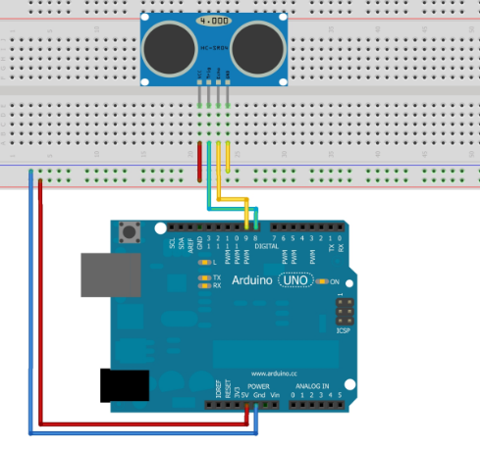

* **Working**:-

First, we created variables for the trigger and echo pin called trigPin and echoPin, respectively. The trigger pin is connected to digital Pin 9, and the echo pins is connected to digital pin 10.

We also created 3 variables of type long: duration, cm and inch. The duration variable saves the time between the emission and reception of the signal. The cm variable will save the distance in centimeters, and the inch variable will save the distance in inches.

1. In the setup(), initialize the serial port at a baud rate of 9600, and set the trigger pin as an output and the echo pin as an input.
2. In the loop(), trigger the sensor by sending a HIGH pulse of 10 microseconds. But, before that, give a short LOW pulse to ensure you’ll get a clean HIGH pulse.
3. Then, you can read the signal from the sensor – a HIGH pulse whose duration is the time in microseconds from the sending of the signal to the reception of its echo to an object.
4. Finally, you just need to convert the duration to a distance. We can calculate the distance by using the following formula:-

**distance = (traveltime/2) x speed of sound**

The speed of sound is: 343m/s = 0.0343 cm/uS = 1/29 cm/uS

Or in inches: 13503.9in/s = 0.0135in/uS = 1/74in/uS

We need to divide the traveltime by 2 because we have to take into account that the wave was sent, hit the object, and then returned back to the sensor.

cm = (duration/2) / 29;

inches = (duration/2) / 74;

1. Finally, we print the results in the Serial Monitor.

* **Output**:-

